**Installation and User Guide for JAVA Prototype**

**Group C**

**1.PREPARATION**

Before starting, you should have the running environment set up properly. The following software applications are necessary:

* NETBEANS IDE and JDK

http://dlc.sun.com.edgesuite.net/netbeans/8.0/rc/

* ORACLE JDBC Drivers installed in your local Java library

http://www.oracle.com/technetwork/database/enterprise-edition/jdbc-112010-090769.html

* JAVA Source Code (included in the package)

BarkleyBrothers.zip

**2. INSTALLATION**

Import source code using NetBeans

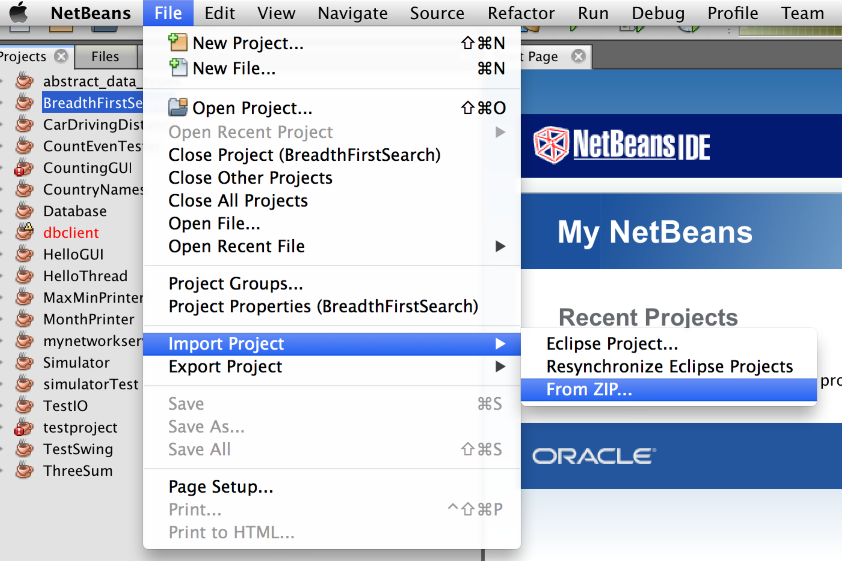

Select the path where you place the source code folder and then press import.

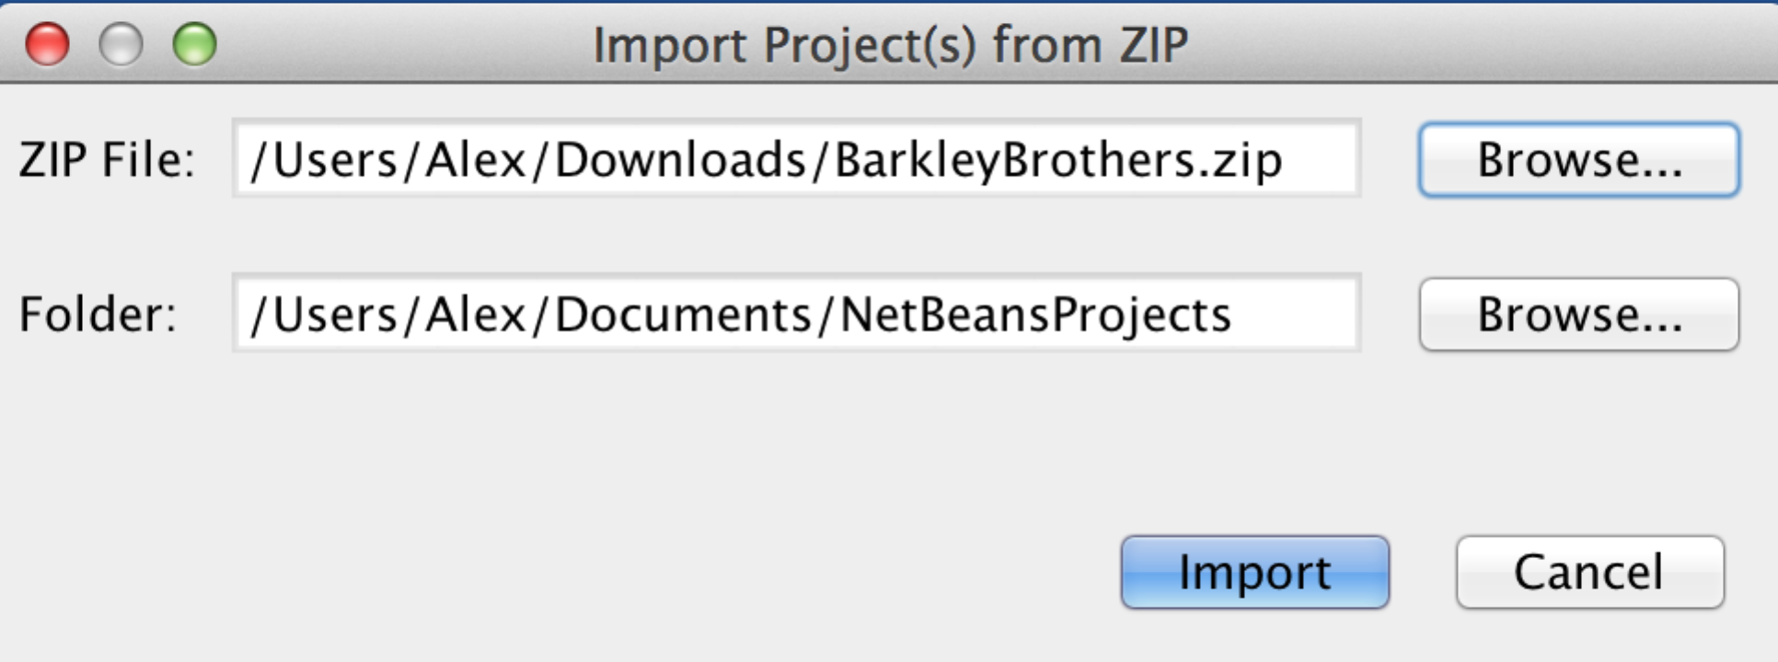

Now you should be able to see this project in your project list

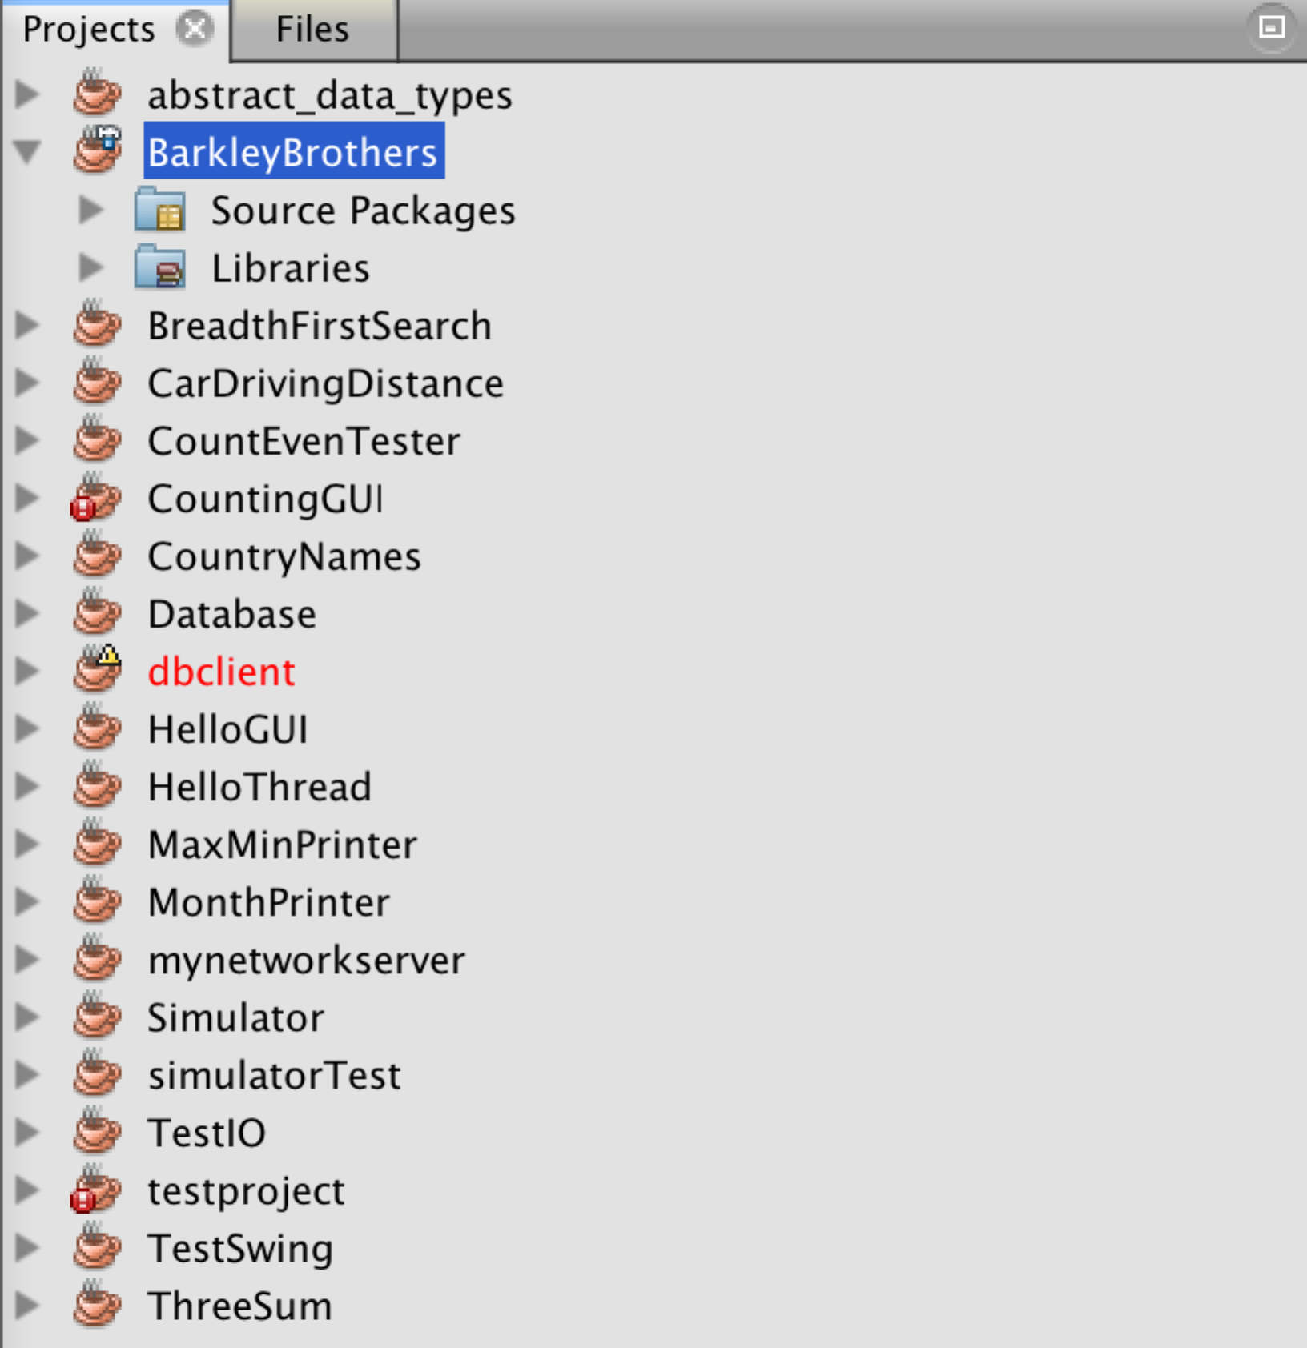

Now you already have this application properly installed in your local machine. You could start to test its functions.

**3. EXECUTING**

Select the project from NetBeans and press run to boot up this application. You are going to see the application UI below. Press the Start button located at upper left to connect to the database (This application is connected to my team1 account. If you want to connect other Oracle instance, you have to change the configuration inside the code).

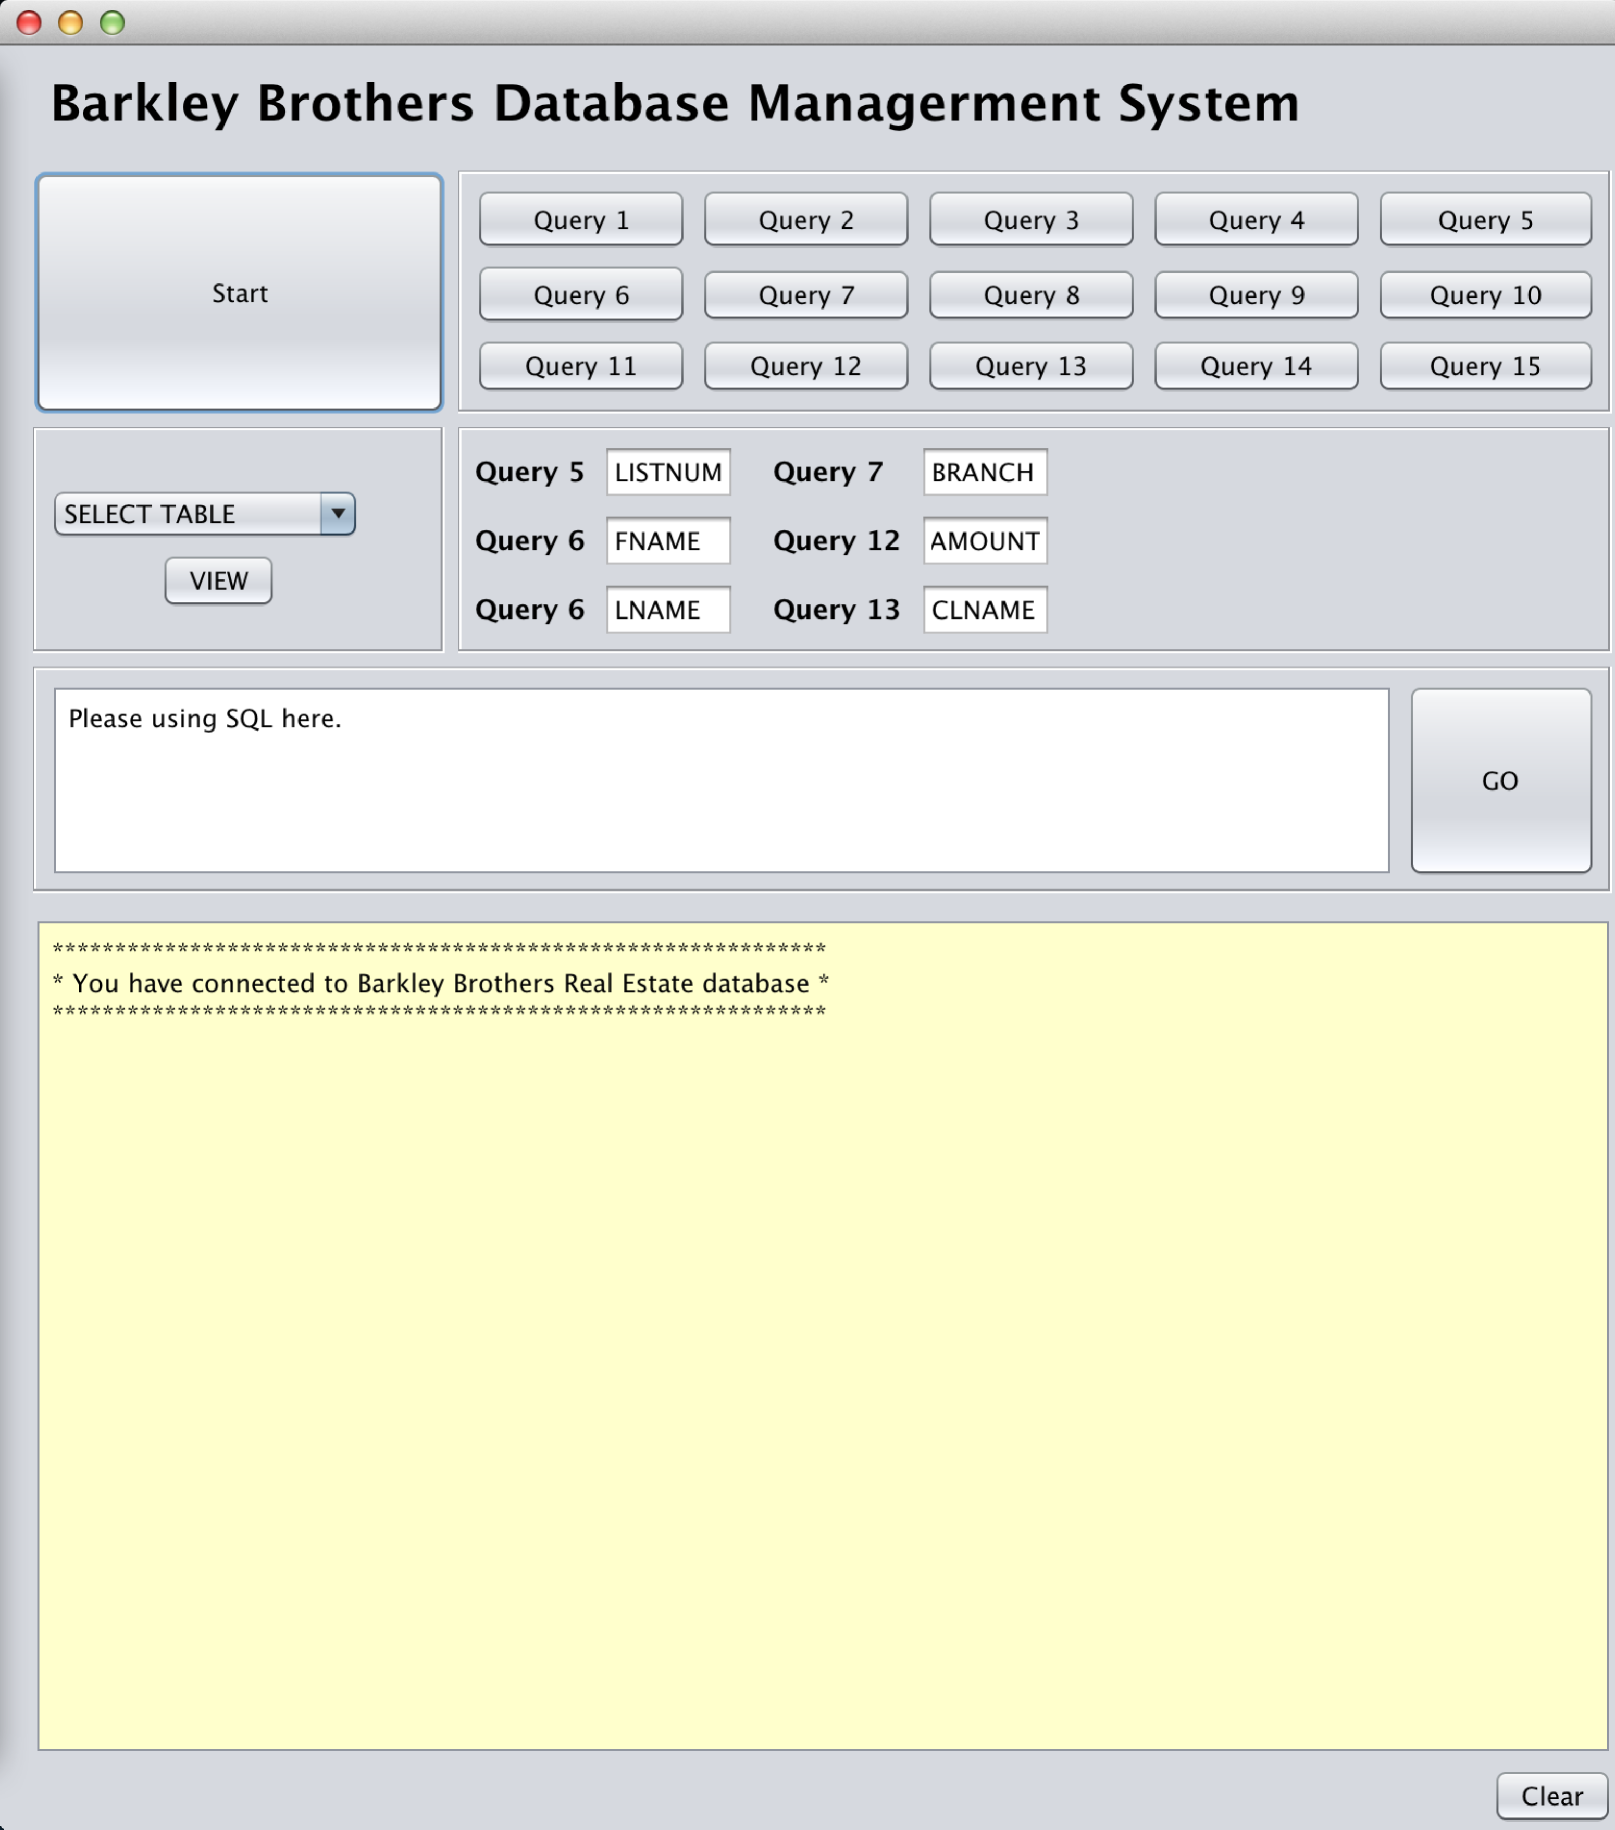

To view each table, select form the drop down menu and press view.

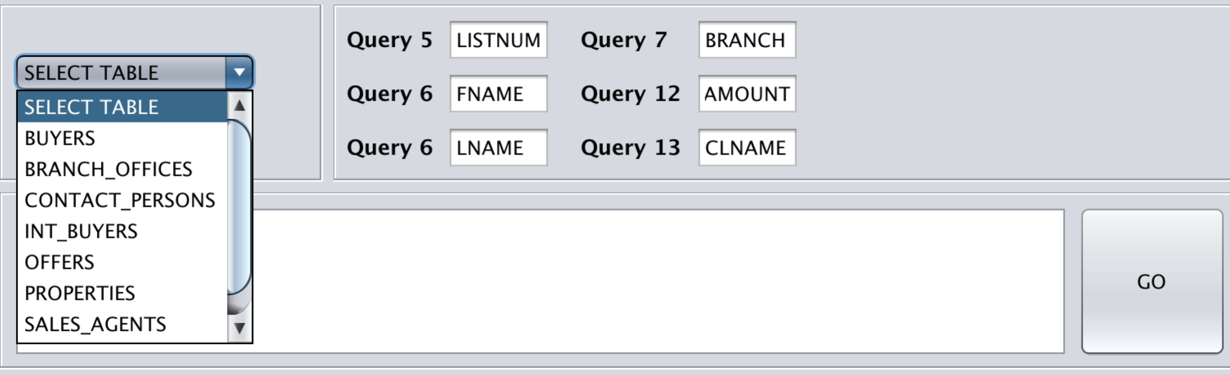

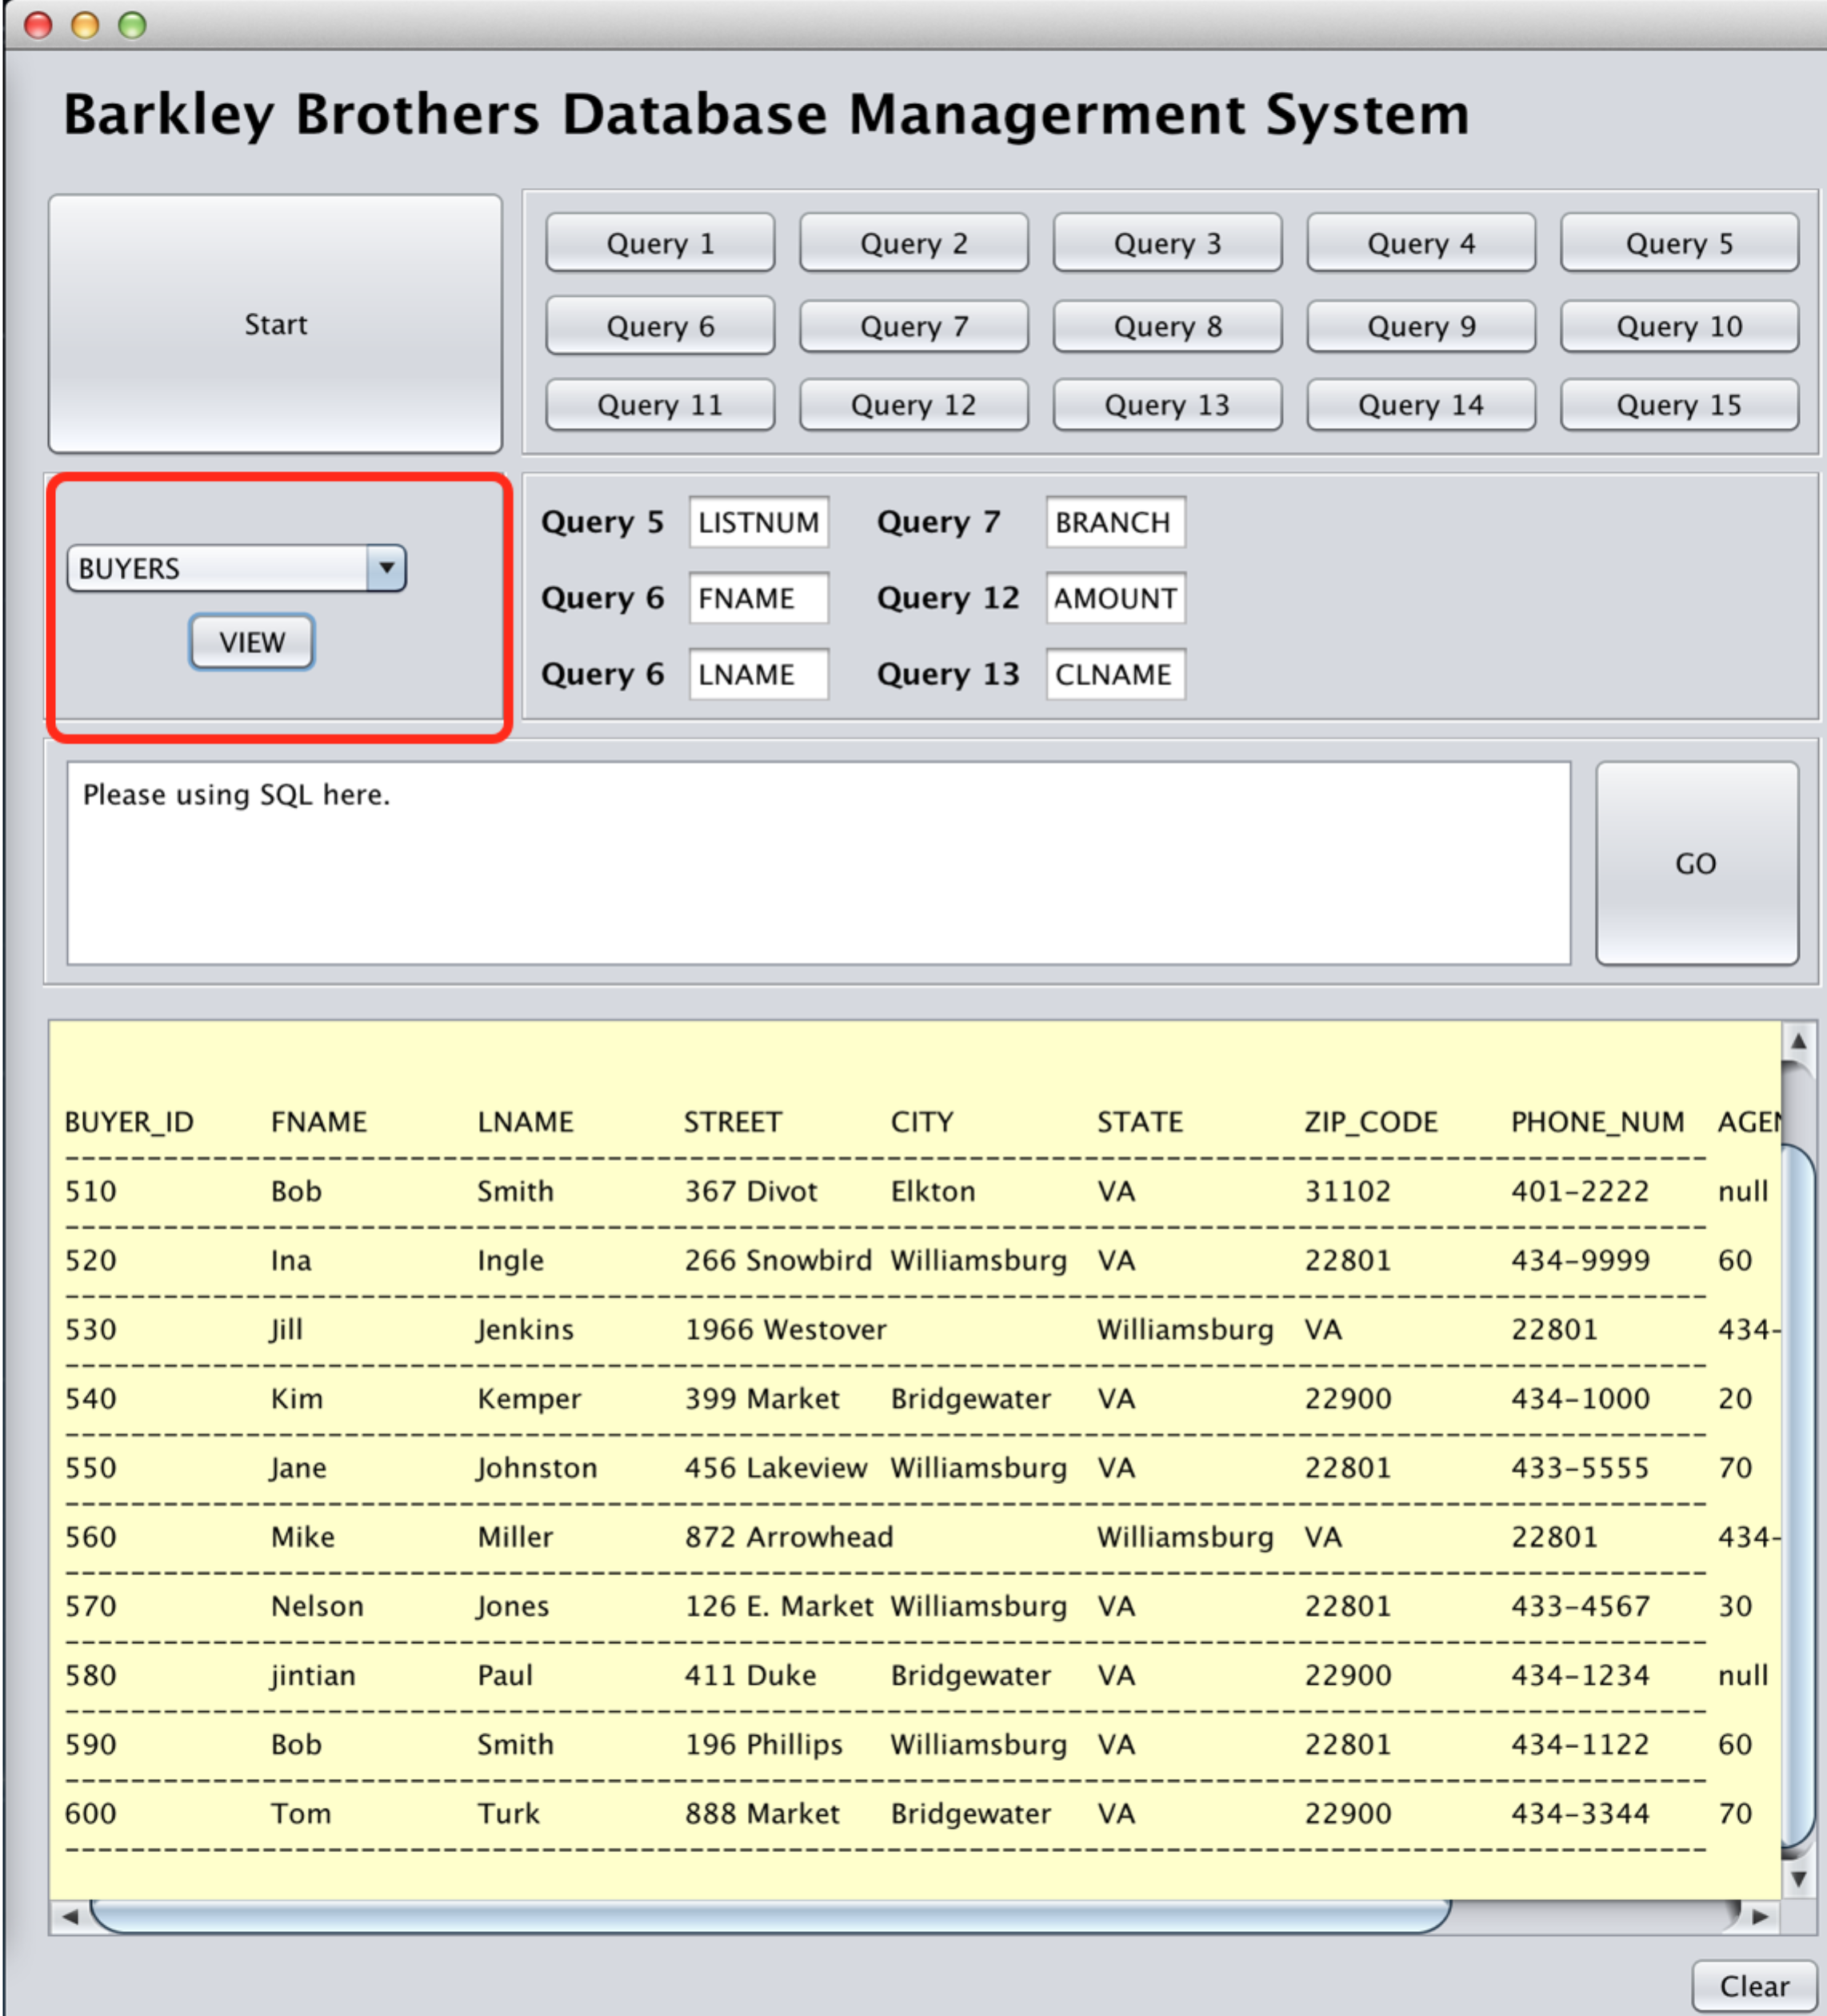

To execute the built-in query, provide your input first and press corresponding query bottom (The queries are implemented till query 7. The others are left blank for future use). The input fields are **not case sensitive**. You only need make sure there is no typo.

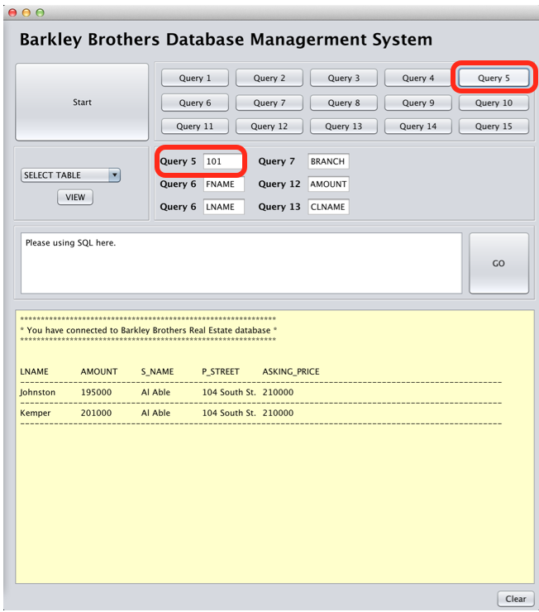

You can also write your SQL query and directly fetch data from your database. It’s the exactly the same SQL query you used in Oracle data developer.

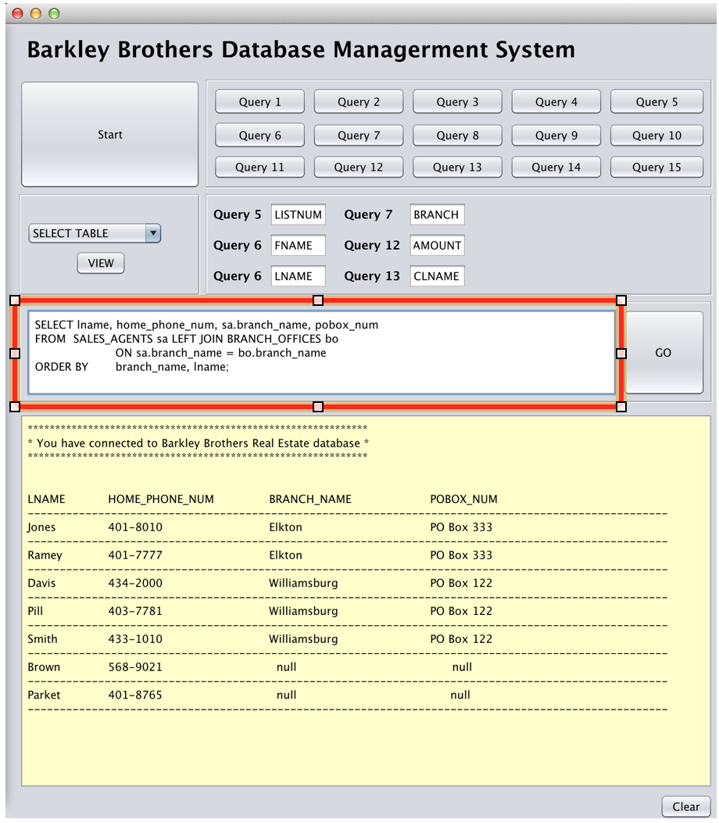

The **Clear** button located at the bottom right can erase all data in the output windows.

You can use this function to clean up the window.

**4. SUMMARY**

This is an overlook of the JAVA prototype designed for this team project. It recreated some function of the ORACLE Developer, like executing the SQL query. Some improvement is done based on that.

* User can build in common used query. It saves your time by not typing the same query time all the time.
* The input is not case sensitive. You only need to make sure there is no typo. You will get your expecting data.
* Simple user interface focusing on the core applications